A FIELD PROJECT REPORT ON

**“PERSONAL PORTFOLIO WEBSITE”**

Submitted in partial fulfilment of the requirements for the award of the degree

**BACHELOR OF TECHNOLOGY**

in

**(COMPUTER SCIENCE ENGINEERING)**

Submitted by

|  |  |
| --- | --- |
| N.Charan Tej | (231FA04A26) |
| M.Teja | (231FA04A37) |
| K.Mansoor | (231FA04A47) |
| D.Raghu Ram | (231FA04E72) |



Department of COMPUTER SCIENCE ENGINEERING

Vignan’s Foundation for Science, Technology and Research (Deemed to be University) Vadlamudi, Guntur, Andhra Pradesh-522213, India

**March – 2025**



**CERTIFICATE**

This is to certify that the field project entitled “**PERSONAL PORTFOLIO WEBSITE**” being submitted by (N.Charan Tej 231FA04A26), (M.Teja & 231FA04A37), (K.Mansoor & 231FA04A47), and (D.Raghu Ram & 231FA04E72) in partial fulfilment of Bachelor of Technology in the Department of COMPUTER SCIENCE ENGINEERING, Vignan’s Foundation For Science Technology & Research (Deemed to be University), Vadlamudi, Guntur District, Andhra Pradesh, India, is a bonafide work carried out by them under my guidance and supervision.

Dr. S.V Phani Kumar Mr.K.Pavan Kumar

|  |  |
| --- | --- |
| **Head of the Department**  **CSE** | **Guide** |

**DECLARATION**

We hereby declare that our project work described in the field project titled “**PERSONAL** **PORTFOLIO WEBSITE**” which is being submitted by us for the partial fulfilment in the department of **COMPUTER SCIENCE ENGINEERING**, Vignan’s Foundation for Science, Technology and Research (Deemed to be University), Vadlamudi, Guntur, Andhra Pradesh, and the result of investigations are carried out by us under the guidance of Mr.K.Pavan Kumar

|  |  |  |
| --- | --- | --- |
| N.Charan Tej | (231FA04A26) |  |
| M.Teja | (231FA04A37) |  |
| K.Mansoor | (231FA04A47) |  |
| D.Raghu Ram | (231FA04E72) |  |

**TABLE OF CONTENTS**

|  |  |  |  |
| --- | --- | --- | --- |
| **Chapter No.** | | **Contents** | **Page No** |
| **1** |  | **Introduction** |  |
|  | **1.1** | **Problem Definition** |  |
|  | **1.2** | **Existing System** |  |
|  | **1.3** | **Proposed System** |  |
|  | **1.4** | **Literature Review** |  |
| **2** |  | **System Requirements** |  |
|  | **2.1** | **Hardware & Software Requirements** |  |
|  | **2.2** | **Software Requirements Specification(SRS)** |  |
| **3** |  | **System Design** |  |
|  | **3.1** | **Modules of System** |  |
|  | **3.2** | **UML Diagrams** |  |
| **4** |  | **Implementation** |  |
|  | **4.1** | **Sample Code** |  |
|  | **4.2** | **Test Cases** |  |
| **5** |  | **Results** |  |
|  | **5.1** | **Output Screens** |  |
| **6** |  | **Conclusion** |  |
|  |  | **References** |  |

# **“Personal Portfolio Website”**

## **Chapter 1: Introduction**

A portfolio website is a crucial tool for professionals across various industries, and its necessity stems from several key reasons like **Showcasing Skills and Work** , **Searchability and Online Presence** , **Demonstrating Growth and Progress** , **Career Advancement and Networking** etc.

that is why portfolio website project is a versatile and powerful tool which plays a pivotal role in establishing a professional identity, creating opportunities, and facilitating meaningful connections in today's interconnected world.

### 1.1 Problem Definition

### It is not possible to test or showcase our skills by interacting with each person that is why everyone in the tech industry needs an e portfolio which can reflect the persons capabilities , his work and contact details. Each tech industry needs a good employee having set of technological knowledge and e-portfolio will help you to show case your skills and work.

### 1.2 Existing System

The traditional methods for showcasing personal profiles include resumes, LinkedIn profiles, and third-party portfolio sites. However, these methods have limitations such as:

* Lack of personalization and customization
* Limited interactive features
* Dependence on third-party platforms

### 1.3 Proposed System

The proposed system is a personal portfolio website that provides a customized, interactive, and visually appealing way to present professional details. It includes features such as:

* Home page with a personal introduction
* About section with skills and experience
* Portfolio section displaying projects
* Contact form for networking
* Blog section (optional) for sharing insights

### 1.4 Literature Review

Several studies and articles highlight the importance of online portfolios in career advancement. Research suggests that personalized portfolio websites help professionals stand out in competitive job markets by demonstrating technical and creative skills effectively.

## **Chapter 2: System Requirements**

### 2.1 Hardware & Software Requirements

#### Hardware:

* **Processor**: Intel core i3 or above for a stable experience and fast retrieval of data.
* **Hard Disk**: 2GB and above
* **RAM**: 256 MB or more, recommended 2 GB for fast reading and writing capabilities which will result in better performance time.

#### Software:

This software package is developed using html , CSS for frontend and JavaScript for the backend. Using Vs Code as a text editor and Google Chrome for the execution of our code.

Required Specifications for our Device:

* **Operating System**: Windows 7, 8, 9, 10 .
* **Language**: Html , CSS , JavaScript.
* **Text Editor**: Vs Code.
* **Extension**: Live Server

### 2.2 Software Requirements Specification (SRS)

**Functional Requirements:**

* User-friendly navigation
* Responsive design for different screen sizes
* Contact form with email integration
* Portfolio section with images and descriptions

**Non-Functional Requirements:**

* Fast loading speed
* SEO optimization
* Secure contact form
* Mobile responsiveness

## **Chapter 3: System Design**

### 3.1 Modules of System

* **Home Page:** Introduction and personal details
* **About Page:** Skills, education, and work experience
* **Portfolio Page:** Showcases projects with descriptions
* **Contact Page:** Contact form with social media links
* **Blog Section (Optional):** A place to share articles and experiences

### Lightbox

### 3.2 UML Diagrams

* Use Case Diagram: Defines how users interact with the system

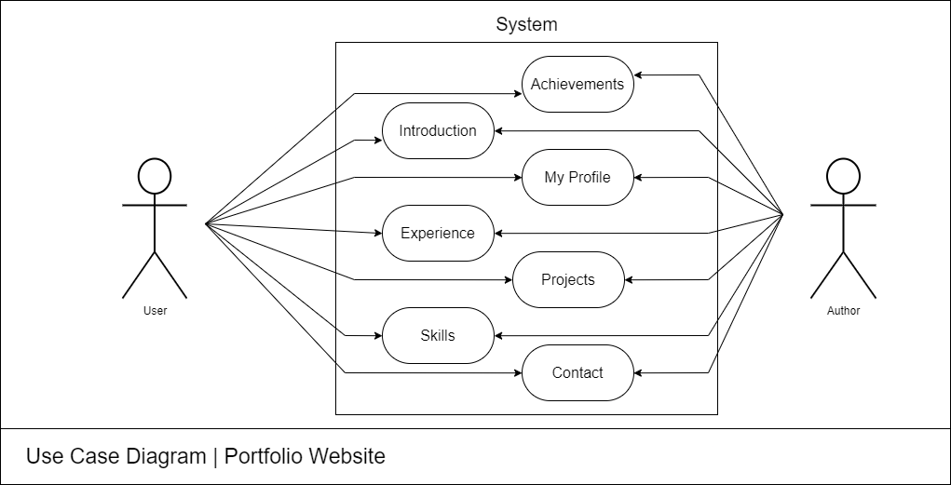

## **Chapter 4: Implementation**

### 4.1 Sample Code

### <!DOCTYPE html>

<html>

### <head>

### <meta charset="utf-8">

### <meta name="viewport" content="width=device-width, initial-scale=1">

### <title>User Portfolio</title>

### <!---custom css link--->

### <link rel="stylesheet" type="text/css" href="C:\Users\LENOVO\Documents\FP projects\portfolio.css">

### <link rel="stylesheet"

### href="C:\Users\LENOVO\Documents\FP projects\portfolio.css">

### <link rel="preconnect" href="https://fonts.googleapis.com">

### <link rel="preconnect" href="https://fonts.gstatic.com" crossorigin>

### <link href="https://fonts.googleapis.com/css2?family=Quicksand:wght@300;400;500;600;700&display=swap" rel="stylesheet">

### <link href="https://fonts.googleapis.com/css2?family=Baloo+Bhai+2&family=Lato:wght@300&family=Poppins&family=Roboto:ital,wght@1,300&display=swap" rel="stylesheet">

### </head>

### <body>

### <!---header--->

### <header>

### <h2 class="logo">Portfo<span>lio</span></h2>

### <ul class="navbar">

### <li><a href="#home">Home</a></li>

### <li><a href="#about">About Me</a></li>

### <li><a href="#experience">Experience</a></li>

### <li><a href="#skills">Skills</a></li>

### <li><a href="#achievement">Achievements</a></li>

### <li><a href="#portfolio">Projects</a></li>

### <li><a href="#contact">Contact</a></li>

### </ul>

### </header>

### <!---home--->

### <section class="home" id="home">

### <video autoplay loop muted plays-inline class="back-video">

### <source src="C:\Users\LENOVO\Documents\FP projects\videos\portfolio.mp4" type="video/mp4">

### </video>

### <div class="home-text">

### <h3>Hello</h3>

### <h1>I'm NANDHALAL <br> <span></span></h1>

### <h3>Software Developer and Programming Enthusiast </h3>

### <a href="C:\Users\LENOVO\Documents\FP projects\Resume.pdf" class="btn" target="_blank">Download Resume</a>

### </div>

### </section>

### <!---about--->

### <section class="about" id="about">

### <div class="about-img">

### <img src="C:\Users\LENOVO\Documents\FP projects\images\profilepic.jpeg">

### </div>

### <div class="about-text">

### <h2>About Me</h2>

### <h4>Hi, My name is Nandha Lal!!</h4>

### <p>I am a B.Tech Final Year Student of Vignan University College-Guntur, Pursuing My Degree in Vignan University College . I have a keen Interest in Problems Solving and Finding new and Dynamic Ideas.</p><br>

### <p>I am a Machine Learning Enthusiast & Front-end Web Developer. I can provide clean code and pixel perfect design.</p>

### <div class="about-gri">

### <div class="about-in">

### <h5>1. Problem Solving</h5>

### </div>

### <div class="about-in">

### <h5>2. DSA</h5>

### </div>

### <div class="about-in">

### <h5>3. Machine Learning</h5>

### </div>

### <div class="about-in">

### <h5>4. Web Development</h5>

### </div>

### </div>

### <a href="#contact" class="btn">Contact Me</a>

### </div>

### </section>

### <!-- Technical Languages -->

### <div class="inner">

### <div class="Tech_header">

### <h1>Languages</h1>

### </div>

### <div class="Tcontainer">

### <div class="skill-box">

### <div class="skill-title">

### <div class="tech_img">

### <img class="skill-icon" src="C:\Users\LENOVO\Documents\FP projects\images\c.png" alt="C Programming Language">

### </div>

### <h3>C</h3>

### </div>

### </div>

### <div class="skill-box">

### <div class="skill-title">

### <div class="tech_img">

### <img class="skill-icon" src="C:\Users\LENOVO\Documents\FP projects\images\C++.png" alt="C++ Programming Language">

### </div>

### <h3>C++</h3>

### </div>

### </div>

### <div class="skill-box">

### <div class="skill-title">

### <div class="tech_img">

### <img class="skill-icon" src="C:\Users\LENOVO\Documents\FP projects\images\html.png" alt="Html">

### </div>

### <h3>HTML</h3>

### </div>

### </div>

### <div class="skill-box">

### <div class="skill-title">

### <div class="tech_img">

### <img class="skill-icon" src="C:\Users\LENOVO\Documents\FP projects\images\css.png" alt="Css">

### </div>

### <h3>Css</h3>

### </div>

### </div>

### <div class="skill-box">

### <div class="skill-title">

### <div class="tech_img">

### <img class="skill-icon" src="C:\Users\LENOVO\Documents\FP projects\images\js.png" alt="JavaScript">

### </div>

### <h3>JavaScript</h3>

### </div>

### </div>

### <div class="skill-box">

### <div class="skill-title">

### <div class="tech_img">

### <img class="skill-icon" src="C:\Users\LENOVO\Documents\FP projects\images\python.png" alt="Python">

### </div>

### <h3>Python</h3>

### </div>

### </div>

### </div>

### </div>

### 

### <!-- -Experience- -->

### <section class="experience" id="experience">

### <div class="main-text">

### <h2>My Experiences</h2>

### </div>

### <br>

### <div class="experience-content">

### <div class="box">

### <img src="C:\Users\LENOVO\Documents\FP projects\images\My Experiences.png" >

### <h4>

### <span>

### Technical Content Writer

### </span>

### </h4>

### <br>

### <p>

### • Created Multiple Software Development Projects with their detailed Documentation.

### <br>

### • Worked with the Dynamic Team of GeeksforGeeks.

### </p>

### </div>

### </div>

### </section>

### <!-- -Skills- -->

### <section class="skills" id="skills">

### <div class="main-text">

### <h2>My Skills</h2>

### </div>

### <div class="skills-content">

### <div class="box">

### <img src="C:\Users\LENOVO\Documents\FP projects\images\Competitive Programming.jpg" >

### <h3>Competitive Programming</h3>

### <p>

### Competitive programming is a sport of coding, where individuals engage in solving algorithmic challenges against the clock, showcasing their problem-solving skills and efficiency in crafting elegant and optimized solutions.</p>

### </div>

### <div class="box">

### <img src="C:\Users\LENOVO\Documents\FP projects\images\FED.jpg" >

### <h3>Front-end Development</h3>

### <p>Front-end development is the art of bringing digital creativity to life, focusing on the user interface and user experience to seamlessly merge design with functionality, shaping the visual and interactive elements of websites.</p>

### </div>

### <div class="box">

### <img src="C:\Users\LENOVO\Documents\FP projects\images\ML.jpg">

### <h3>Machine Learning</h3>

### <p>Machine learning is a transformative field at the intersection of computer science and A.I., empowering systems to learn from data, recognize patterns, and make intelligent decisions, entering in a automated insights and problem-solving.</p>

### </div>

### </div>

### </section>

### <!-- -Achievements- -->

### <section class="achievement" id="achievement">

### <div class="main-text">

### <h2>My Achievements</h2>

### <h4>Some of My Major Achievements</h4>

### </div>

### <div class="portfolio-content">

### <div class="row">

### <img src="C:\Users\LENOVO\Documents\FP projects\images\coding.jpeg">

### <div class="main-row">

### <div class="row-text">

### <h6>Here are some Coding achievements achieved by Me</h6>

### </div>

### </div>

### <h3>

### <ol>

### <li>1.Developed a Full-Stack Portfolio Website.</li>

### <li>2.Completed 100+ Coding Challenges on LeetCode & CodeChef.</li>

### <li>3.Built an AI-Based Chatbot.</li>

### <li>4.Won a Hackathon or Coding Competition.</li>

### <li>5.Worked on a Machine Learning Project.</li>

### </ol>

### </h3>

### </div>

### <div class="row">

### <img src="C:\Users\LENOVO\Documents\FP projects\images\hackathons.avif">

### <div class="main-row">

### <div class="row-text">

### <h6>Here are some Hackathons achievements achieved by Me</h6>

### </div>

### </div>

### <h3>

### <ol>

### <li>1.Winner of NASA Space Apps Challenge.</li>

### <li>2.Finalist in Microsoft Imagine Cup.</li>

### <li>3.Top 10 in Smart India Hackathon (SIH).</li>

### <li>4.Best FinTech Innovation at HackZurich.</li>

### <li>5.Top 3 in Junction Hackathon.</li>

### </ol>

### </h3>

### </div>

### <div class="row">

### <img src="C:\Users\LENOVO\Documents\FP projects\images\sports.jpg">

### <div class="main-row">

### <div class="row-text">

### <h6>Here are some Extra curricular achievements achieved by Me</h6>

### </div>

### </div>

### <h3>

### <ol>

### <li>1.Winner of District-Level Football Championship.</li>

### <li>2.Best Player Award in Volleyball at Inter-School Sports Meet.</li>

### <li>3.Bronze Medalist in Taekwondo at National Martial Arts Championship.</li>

### <li>4.Winner of the Annual Marathon at City Sports Festival.</li>

### </ol>

### </h3>

### </div>

### 

### </div>

### </section>

### 

### <!-- -portfolio- -->

### <section class="portfolio" id="portfolio">

### <div class="main-text">

### <h2>My Projects</h2>

### <h4>Some Of My Distinguished Works</h4>

### </div>

### <div class="portfolio-content">

### <div class="row">

### <a href="https://www.geeksforgeeks.org/library-management-system/" target="_blank">

### <img src="C:\Users\LENOVO\Documents\FP projects\images\LM.jpg">

### </a>

### <div class="main-row">

### <div class="row-text">

### <h6>Web App development</h6>

### </div>

### </div>

### <h3>Library Management System</h3>

### </div>

### <div class="row">

### <a href="" target="_blank">

### <img src="C:\Users\LENOVO\Documents\FP projects\images\weather.avif">

### </a>

### <div class="main-row">

### <div class="row-text">

### <h6>Web App Development</h6>

### </div>

### </div>

### <h3>Weather Forecasting App</h3>

### </div>

### 

### <div class="row">

### <a href="https://www.geeksforgeeks.org/dog-breed-classification-using-transfer-learning/" target="_blank">

### <img src="C:\Users\LENOVO\Documents\FP projects\images\DBC.avif">

### </a>

### <div class="main-row">

### <div class="row-text">

### <h6>Machine Learning</h6>

### </div>

### </div>

### <h3>Dog's Breed Classification</h3>

### </div>

### <div class="row">

### <a href="https://www.geeksforgeeks.org/ml-boston-housing-kaggle-challenge-with-linear-regression/" target="_blank">

### <img src="C:\Users\LENOVO\Documents\FP projects\images\BHPP.jpeg">

### </a>

### <div class="main-row">

### <div class="row-text">

### <h6>Machine Learning</h6>

### </div>

### </div>

### <h3>Boston House Price Prediction</h3>

### </div>

### </div>

### </section>

### <!-- -POR- -->

### <section class="POR" id="POR">

### <div class="main-text">

### <h2>Position of Responsibilities</h2>

### <h4>Some of My valunteer Work</h4>

### </div>

### <div class="portfolio-content">

### <div class="row">

### <img src="C:\Users\LENOVO\Documents\FP projects\images\speaker.jpg">

### <div class="main-row">

### <div class="row-text">

### <h6>GFG College Chapter</h6>

### </div>

### </div>

### <h3>President</h3>

### </div>

### <div class="row">

### <img src="C:\Users\LENOVO\Documents\FP projects\images\chess.jpg">

### <div class="main-row">

### <div class="row-text">

### <h6>Chess Coordinator</h6>

### </div>

### </div>

### <h3>College Chess Club</h3>

### </div>

### </div>

### </section>

### <!-- -contact- -->

### <section class="contact" id="contact">

### <div class="contact-text">

### <h2>Contact Me</h2>

### <h4>Let's Work Together</h4>

### <p>I will Help you in your next Project, Contact me through details given below .</p>

### <div class="contact-list">

### <li><a href="#">Tenali</a></li>

### <li><a href="#">mutheteja@gmail.com</a></li>

### <li><a href="#">+91 8885627075</a></li>

### <a href="mailto: mutheteja@mail.com">

### <button class="btn">

### Let's Chat

### </button>

### </a>

### </div>

### </div>

### </section>

### <!---scroll-top--->

### <a href="#" class="top"><i class='bx bx-up-arrow-alt' ></i></a>

### <script src="https://unpkg.com/scrollreveal"></script>

### <!---custom js link--->

### <script type="text/javascript" src="C:\Users\LENOVO\Documents\FP projects\portfolio.js"></script>

### </body>

### </html>

### 4.2 Test Cases

|  |  |
| --- | --- |
| **Test Case** | **Expected Output** |
| Home page loads properly | Displays home page content |
| Navigation links work | Redirects to respective sections |
| Contact form submission | Shows success message or sends email |
| Responsive design | Proper layout on mobile and desktop |

## **Chapter 5: Results**

### 5.1 Output Screens

* Home Page Screenshot

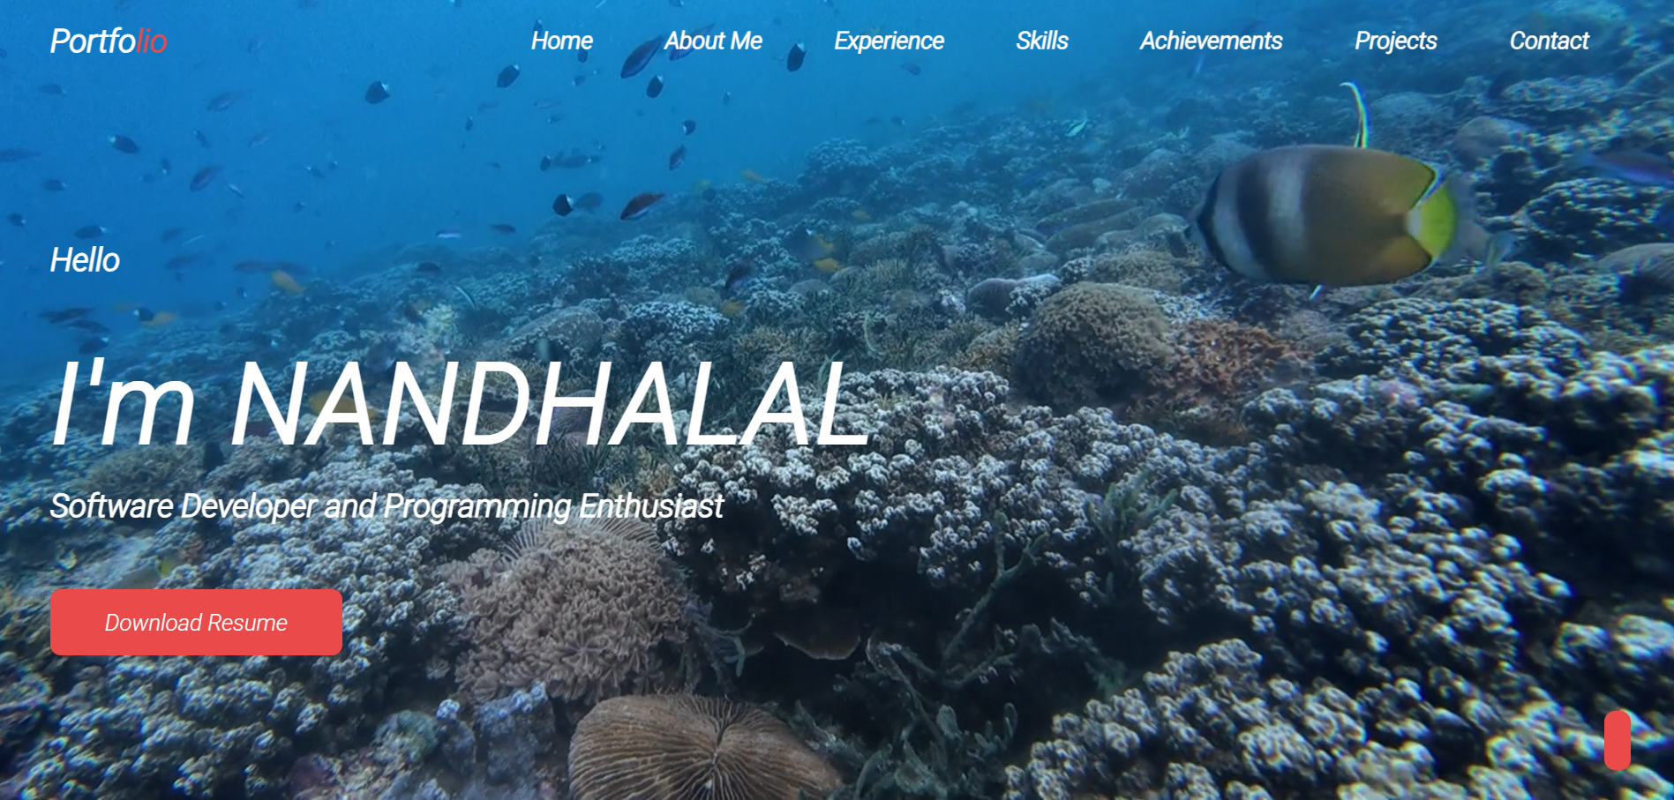

* About Page Screenshot

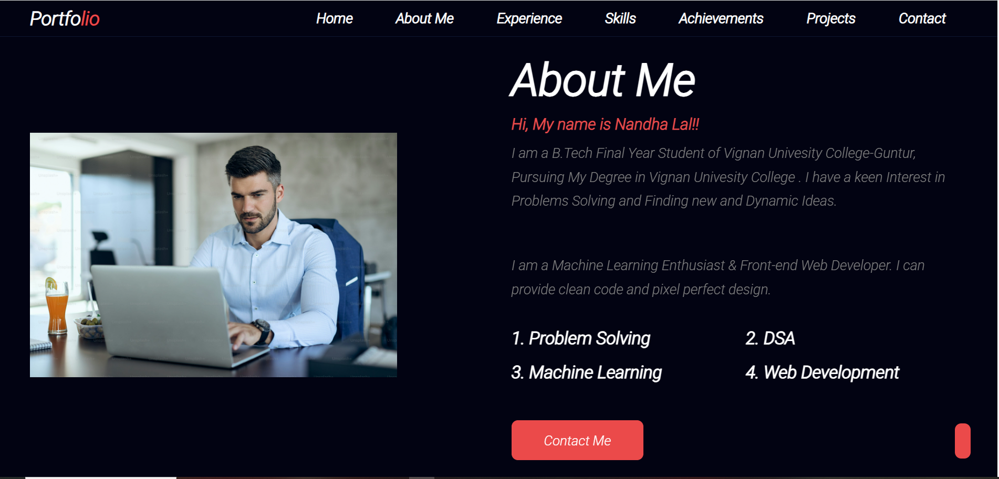

* Languages Page Screenshot

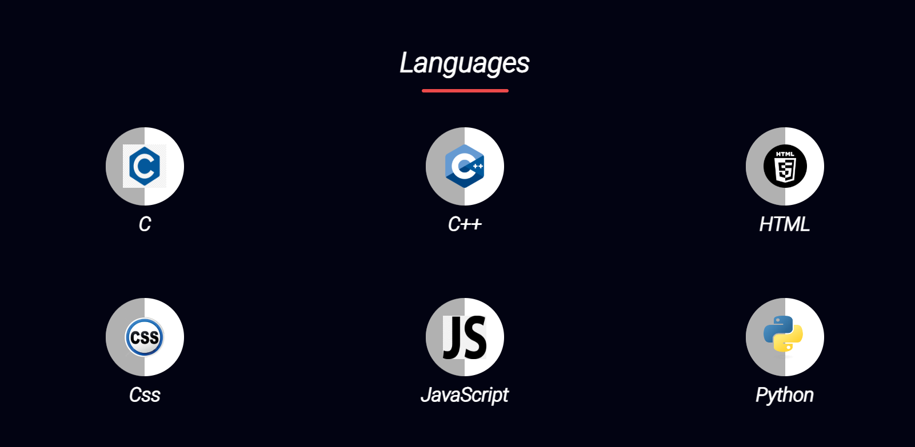

* My Experiences Page Screenshot

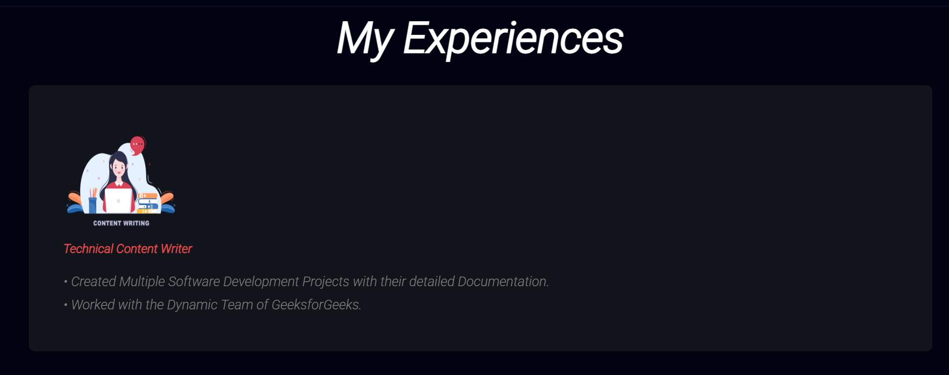

* My Skills Page Screenshot

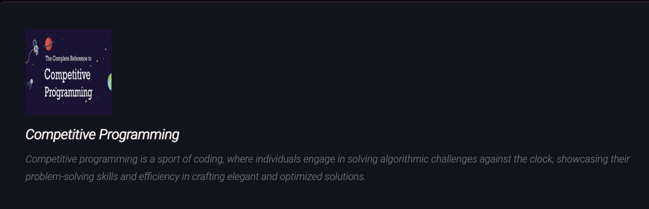

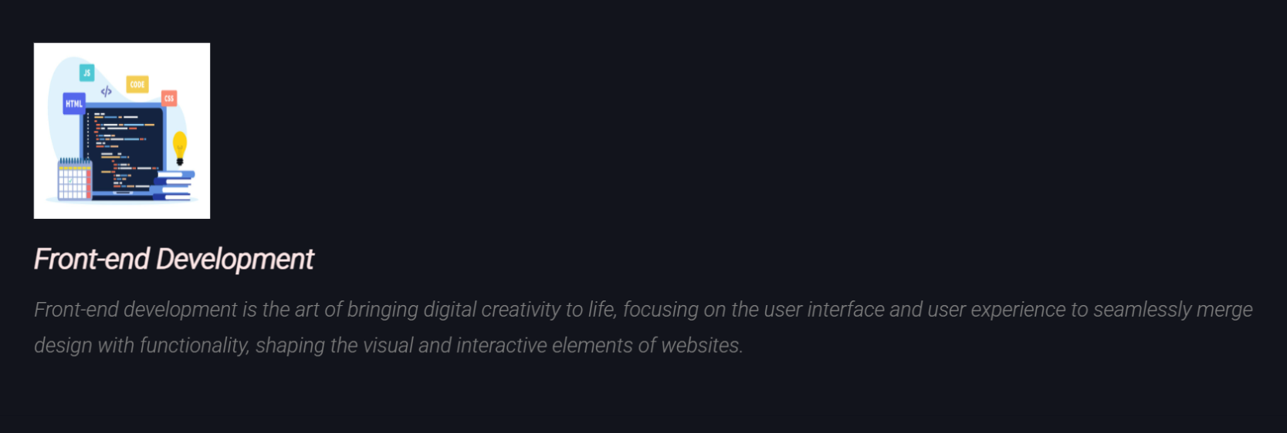



* My Achievements Page Screenshot

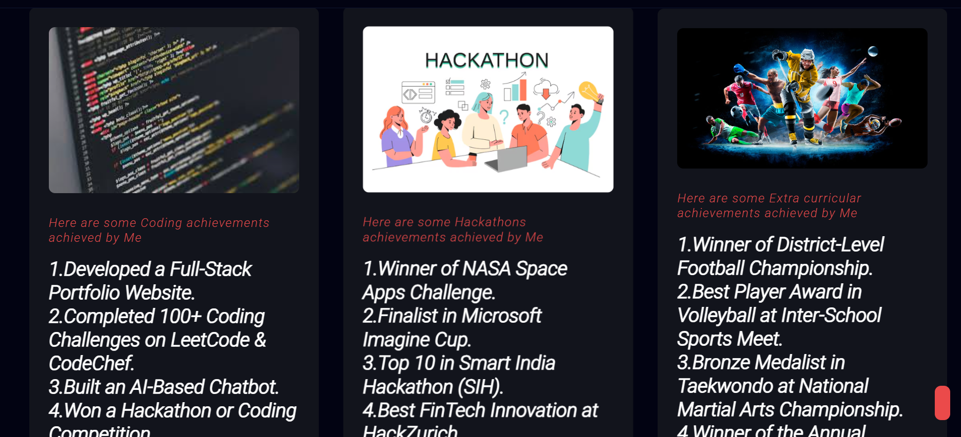

* My Projects Page Screenshot

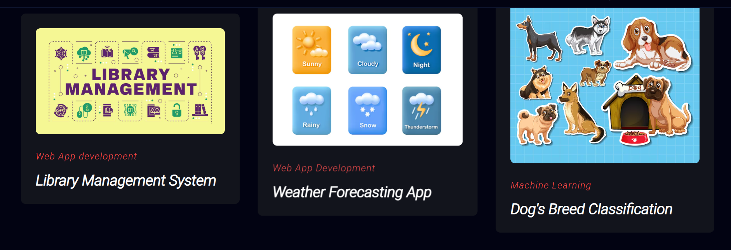

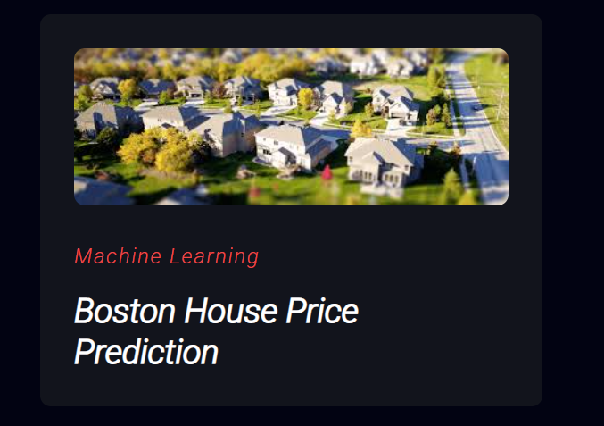

* Position of Responsibilities Page Screenshot

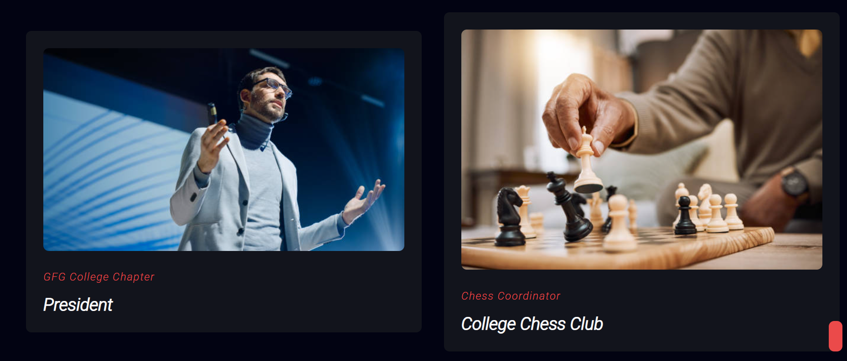

* Contact Page Screenshot

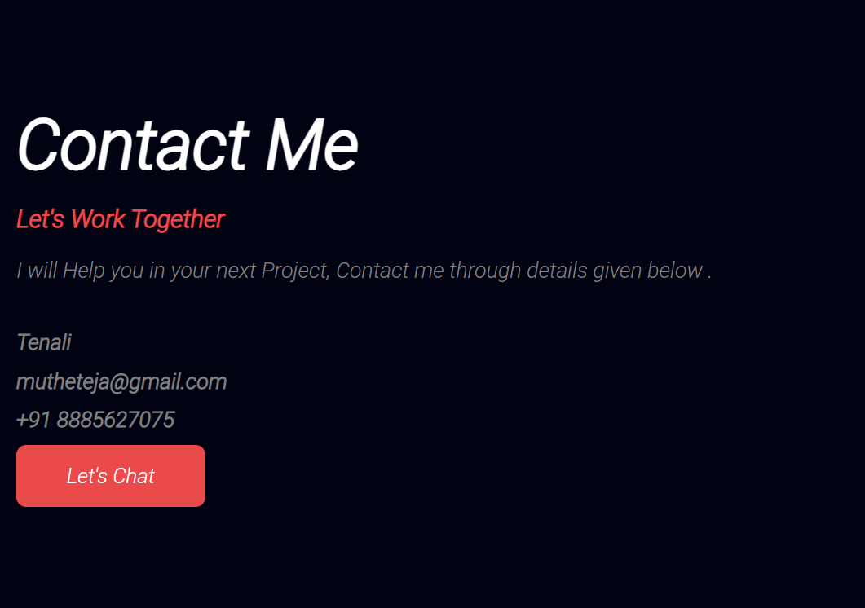

## **Chapter 6: Conclusion**

The personal portfolio website provides a professional and interactive way to showcase an individual’s skills and projects. It enhances online presence and helps in networking opportunities. The key topics covered in this project include:

* **Introduction:** The need for a personal portfolio website
* **System Requirements:** The necessary hardware and software
* **System Design:** The structure and modules of the portfolio
* **Implementation:** Sample code and test cases
* **Results:** Output screens and final presentation

Key components that make a personal portfolio website effective include:

* **Responsive Design:** Ensuring usability on all devices
* **User Experience (UX):** Providing easy navigation and accessibility
* **Interactive Features:** Contact forms, animations, and dynamic content
* **SEO Optimization:** Improving visibility on search engines
* **Security Measures:** Protecting data and user information

Future enhancements can include adding a blog, integrating AI-based chatbots, and including an e-commerce section for freelancers. Additionally, the website can incorporate analytics to track visitor engagement, optimize performance using modern web development techniques, and enhance security features to protect user data. The continuous improvement of the portfolio website will ensure adaptability to industry trends and better career opportunities for users.

### References

* Web Development Documentation
* Online Portfolio Case Studies
* UX/UI Design Principles
* "The Importance of Personal Branding in Digital Spaces" - Research Article
* Google Developers Guide on Web Performance Optimization
* W3C Standards for Web Design and Accessibility